Lebanese American University

School of Arts and Sciences

Software Engineering

CSC490 | Section 11



Instructor: Ibrahim El-Bitar| Project

DTE

Members:

Lama Al Sheikh: 202100077

Ibrahim Al Kotob: 202104079

Razan Ayoub: 202104355

Tamer Kobba: 202104873

**Table of Contents:**

Project Name and Description ………………………………………………….1

Introduction ……………………………………………….....2

Objectives ……………………………….………………….3

Stakeholders …………………………………………………..4

Glossary ..………………………………………………….5

Background ………………………………………………………..6

User Requirements ………………………………………………………..7

Functional Requirements ………………………………………...………………7

Functional Requirements ………………………………………...………………8

Non-Functional Requirements ………………………………………………..…8

System Requirements …………………………………………………….8

Functional Requirements …………………………………………………………8

Functional Requirements …………………………………………………………9

Functional Requirements …………………………………………………………10

Functional Requirements …………………………………………………………11

Functional Requirements …………………………………………………………12

Functional Requirements …………………………………………………………13

Non-Functional Requirements ……………………………………………………13

Non-Functional Requirements ……………………………………………………14

Domain Requirements ……………………………………………………15

Domain Requirements ……………………………………………………16

Phase II ……………………………………………………..17

Software Architecture Design……………………………………………………..18

Software Architecture Design……………………………………………………..19

Use Case Diagram ………………………………………………………20

Description of the use case diagram ……………………………………………..21

Activity Diagram ………………………………………………………..22

Activity Diagram ………………………………………………………..23

Activity Diagram ………………………………………………………..24

Sequence Diagram …………………………………………………………25

Sequence Diagram …………………………………………………………26

Sequence Diagram …………………………………………………………27

Sequence Diagram …………………………………………………………27

Class Diagram …………………………………………………………28

Class Diagram Description ................................................................................29

Class Diagram Description ................................................................................30

Conclusion …………………………………………..………..31

1. ***Project Name and Description:***

Sky Track

SkyTrack (ST) is one of the changes that improve efficiency. ST is involved in the Computer Reservations System and is used for the reservations of a particular airline and interfaces with a Global Distribution System (GDS) which supports travel agencies and other distribution channels in making reservations for most major airlines accessible in a single system.

 SkyTrack contains airline schedules, fare tariffs, passenger reservations, hotel reservations, and ticket records. An airline's direct distribution works within its reservation system and pushes out information to the GDS. A second type of direct distribution channel is consumers who use the internet or mobile applications to make their reservations.

***II. Introduction:***

In the past few years, Horizon Air has emerged as a leading airline company, with a reputation for reliability, efficiency, and innovation. With a focus on customer service and a commitment to safety, Horizon Air has gained a loyal following of passengers who appreciate its high standards and competitive prices.

Driven by its success and its ambitions for growth, Horizon Air recently decided to expand its operations and revamp its management system. The company recognized the need for a more efficient and streamlined approach to managing its resources, including its fleet of aircrafts, crew members, and routes.

To achieve this goal, Horizon Air turned to our team, DTE to create cutting-edge web technologies, developing a web-based management system that would allow it to centralize its operations and automate key tasks. The system leveraged cloud-based infrastructure, enabling real-time data sharing and analysis, as well as enhanced collaboration between different departments and stakeholders.

For this purpose, DTE has started working on the design of an efficient, reliable, and user-friendly management system that makes the lives of customers and employees easier. That way, employees’ productivity, customer satisfaction, and trust are more likely to increase.

SkyTrack is a new Airline Management System (AMS) developed as a web service for Horizon Air. The project aims to facilitate the control of all operations of the airline.

***III – Objectives***

The following objectives are taken into account when designing the AMS:

1. Facilitating the booking process: The objective of facilitating the booking process is to make it easier and more convenient for customers to book flights. This includes the feature of easy online booking and mobile booking. By streamlining the booking process and making it more accessible, the airline management system can improve the overall customer experience, increase customer satisfaction, and ultimately drive more business for the airline.
2. Providing all customers with comfort: the aim is to create a more enjoyable, pleasant, and inclusive travel experience for all customers. This can include features such as comfortable seating, in-flight entertainment, and premium amenities such as meals and drinks. In addition to that, inclusivity is an important goal of Horizon Air, so the airline is providing additional services for passengers with disabilities, certain allergies, or diseases, to make the flight as risk-free as possible. By providing a high level of comfort to all customers, the airline management system can enhance the airline's reputation for quality and service, improve customer loyalty, and attract new customers.
3. Facilitating the job of the employees: The objective of facilitating the job of the employees is to make it easier and more efficient for airline staff to perform their jobs. This can include features such as automated scheduling, real-time tracking of flights and resources, and integrated communication tools. By simplifying and streamlining employee workflows, the airline management system can increase productivity, reduce errors and delays, and improve employee satisfaction and retention.
4. Easy to access, navigate, and control: That is to ensure that all users can interact with the system seamlessly and intuitively. This can include features such as a user-friendly interface, clear navigation paths, and customizable preferences. By making the system easy to use, the airline management system can improve adoption rates, reduce training costs, and increase overall efficiency and effectiveness
5. Safety and Security: The airline management system should prioritize safety and security, ensuring that all flights and operations comply with regulatory requirements and industry standards. By prioritizing safety and security, the airline can build trust with passengers, reduce the risk of accidents or incidents, and minimize liability.

***IV-Stakeholders in the Sky Track system***

Customers: Airline customers, who purchase tickets and other services from the airline, are important stakeholders who expect reliable and safe transportation, good customer service, and competitive pricing.

Shareholders: These are the owners of the airline who have invested money in the company in exchange for ownership. They are interested in maximizing the value of their investment and receiving dividends.

Employees: The airline's employees, including pilots, flight attendants, ground crew, and administrative staff, are critical stakeholders who are interested in job security, fair compensation, and good working conditions.

Customers: Airline customers, who purchase tickets and other services from the airline, are important stakeholders who expect reliable and safe transportation, good customer service, and competitive pricing.

Suppliers: Suppliers of goods and services to the airline, including aircraft manufacturers, fuel providers, catering companies, and maintenance providers, are interested in maintaining good relationships with the airline and receiving timely payment for their services.

Government regulators: Airlines are subject to a range of regulations and oversight by government agencies, such as the Federal Aviation Administration (FAA) in the United States, and these agencies are important stakeholders who are interested in ensuring the safety and security of airline operations.

Local communities: Airline operations can have significant impacts on local communities, such as through noise pollution, traffic congestion, and environmental impacts, and these communities may have an interest in the airline's operations and practices.

***V-Glossary***

Definition of the technical terms used in the document:

DTE: Dora the Explorer

ST: Sky Track

FMS: Flight management system

AMS: Airline management system

GDS: Global Distribution System

***VI- Background***

After checking the airline management systems of various multi-national and international airlines, one can draw a pattern on the services and designs of their websites.

 It is common among most airline companies to provide web services, which include in-flight meals, beverages, entertainment, and baggage handling. That, and airline systems now have online ticketing and reservations that allow passengers to book flights, choose seats, and manage travel arrangements. However, most of these websites are not organized, which makes navigating them and finding the target data a complex task. Not only that, but the airline management system is not transparent with the users, meaning That is why the design of the AMS takes two main unique goals in mind:

Making a user-friendly interface: making the website design appealing and organized and giving the user the freedom to pick the data they are interested in viewing

Partnerships with restaurants/hotels depend on the budget that the user selects. These options can come in bundles with the flight.

Moreover, the system Implements loyalty and rewards programs that offer exclusive benefits and perks to frequent flyers

In addition to common services during flights, Horizon Air provides passengers with health and wellness services such as in-flight yoga, meditation, or massages.

***VII-User Requirements:***

***7.1-Functional Requirements:***

## Log in/Sign in:

Once the user enters the website, they shall have the option to either log in or sign up. The user shall choose to log in, they are prompted to enter their email and password to access their account. If the user doesn’t have an account, they shall choose to create one where they will have to enter their personal information and user data.

## User data

The user shall add user properties like name, detailed address, DOB, nationality, phone number, country, gender, and email.

## Main Page:

After logging in the user shall get access to the main page where all the functionality of the website is available.

## My schedule tab:

  Should appear on the home page and will display Flight properties like Departing/Arriving

City, Departure/Arrival Dates and times, and miles.

## Passenger Preferences:

Passengers shall choose the flight seat properties by identifying seat number, reserved and flight associated to Flight-by-flight number, seat service level, and special needs seat.

Providing a varied list of meals for passengers to choose from (Vegetarian meals, Vegan meals, Fruit platter meals, No fish meals, Kosher meals, Halal meals, Gluten-free meals, Low-fat meals, Low-calorie meals, Seafood meals, Diabetic meals, Low-sodium meal, and Child meal).

The passenger also should choose whether to book the wellness sessions offered during the flight.

## Book a Flight tab:

This feature should appear on the main page.

Booking flights: Users should be able to search for and book flights through the system. The system should provide information on available flights, prices, baggage weight, number of tickets, schedules, and available bundles.

## Loyalty program:

Users should be able to manage their loyalty program accounts through the system. The system should allow users to earn and redeem points, view their account balances, and track their rewards.

## Customer Support:

The system should provide customers with effective customer support options such as online chat, email support, and phone support.

## Flight Scheduling:

The system should allow airline staff to schedule flights, and manage flight routes. Also, pilots are assigned to flights based on their availabilities and aforementioned preferences.

***7.2-Non-Functional Requirements:***

## System ease of access:

The system is a web base, so it shall run on a web browser i.e IE, Chrome, Firefox, etc.

# User Friendliness:

 The system is easy to learn and understand with a simple design. A native user should also use the system effectively, without any difficulties.

***VIII-System Requirements***

***8.1-Functional Requirements:***

# Login/Signup:

When the user is signing up for the account, we should make sure that key information is not redundant or pre-existing already within our database. In the case it is unique, this information is saved into the database, and the account creation is successful. As for when the user is logging in for a pre-existing account, our system must make sure the credentials being entered are available and valid within the database.

# User properties:

The user properties such as name, detailed address, DOB, contact number, email, nationality, gender, the country shall be considered as part of the data model for the airline management system. These properties shall need to be captured and stored in a database system that is part of the overall system architecture. The database system should be designed to support the efficient storage, retrieval, and management of user data.

# My Schedule tab:

It will display an integrated calendar with important dates for the user highlighted, and when interacted with, these days shall display flight properties such as cities, dates, times, and miles are critical for an airline management system. The system should capture, store, and retrieve flight data efficiently. It should also schedule flights, plan routes, manage revenue, analyze data, integrate with other systems, and comply with regulations.

# Passenger properties:

## Flight seat options shall provide features such as seat number, reservation status, flight number, service level, and special needs that matter for the customer, as our customer is our top priority, and providing comfort and preferences comes first. The system should capture, store, and retrieve seat reservation data efficiently. It should also integrate with the booking system and comply with relevant regulations.

## There is the option to order special meals depending on the passenger’s preferences and diet. Upon booking a flight, the user has to select if he wishes to have a meal or more to have during the plane’s time in the air. They shall then select the type of meal based on their diet. The passenger can also provide documentation if they are allergic to certain foods.

## The passenger shall go back and edit their meal preferences no less than 24hrs before flight departure.

## Wellness sessions are provided on board with top life coaches. The passenger can choose to sign up for the session(s) provided during the flight.

## If the flight duration is <3 hours, there should be one session, and if it is > 3 hours, there should be one or more sessions offered that the passenger could sign up for. The passenger can go back and edit their booked session(s) no less than 24 hours before flight departure.

# Book a Flight tab:

## The system requirements for booking flights should enable users to search for flights, provide information on available flights and prices, enable users to book flights, process payments securely and efficiently, provide confirmation and notifications, and integrate with other systems such as airline inventory systems and payment gateways.

## Upon booking a flight, the customer shall be exposed to the available flight bundles. These include bundles with restaurants and hotels or a two-way ticket.

## If the flight is for tourism, the customer will be guided to offers at hotels with luxury night stays depending on their stay, and restaurant or diner reservations can be booked should the user make their choice in selecting one of the bundles offered. The case is similar if the user is booking a business flight. They will be pointed to the world-class hotels the airline partners with annually, in addition to offering reservations for restaurants.

## The process is as such:

## -First prompted to enter the destination you wish to reach

## -Second, the user is asked to choose whether it’s a one- or two-way flight

## -Third, the client must enter the date of arrival, and return if available, the user may also apply additional filters here such as take-off and arrival time, flight price, and flight and hotel package deals, this will check our database for all available flights to the chosen area during those particular dates.

## -Fourth, the client is presented with all the available flights that satisfy the options mentioned above in a simple list including each flight’s serial number, flight take-off and arrival times, seats available on the plane, and price of the flight.

## -Once the user clicks on one of the listed flights, they can enter the number of tickets they wish to book, ages of the passengers, meals for the flight, baggage weight, booking class, in-flight yoga, meditation, breathing exercises, Thai massage, aromatherapy, and during this phase, a very important option is available which is accommodation for people with disabilities.

## -After all the flight details are sorted out, the user can click on the “Book Now” button, and is asked to enter their credit card info.

## -Finally, after the transaction is complete, the user will be able to access the flight from their calendar where they can print the tickets to submit at the airport.

# Loyalty Program:

 The system requirements for a loyalty program should enable users to manage their accounts, earn and redeem points, view their balances, and track their rewards. Reward Redemption comes in the form of certain perks and services on the flight.

# Customer Support:

Located on the main page at the bottom right corner a button with a chat bubble icon titled customer support online chat where the user is connected with a customer support employee to clear up any inquiries. So, if the customer faced any problem, he should contact the IT when he clicks on customer support.

# Employee Access:

The system should provide access to airline employees such as reservation agents, customer service representatives, and administrators.

# User Roles and Permissions:

The system should define user roles and permissions to control access to different parts of the system based on job responsibilities.

# Flight scheduling system requirement:

After a source and destination are picked, the administrator shall follow the following steps:1. Finding an available plane 2. Assigning a pilot to the plane based on their schedule and preferences3. Assigning life a coach, medics, and flight attendants and assign them to the flights based on their availability4. Contacting food suppliers and chefs to ensure that all meal plans for the different diets are offered.

1. Global Distribution System (GDS):

Many airlines use a GDS to connect with travel agents and other airlines. The airline reservation system should be able to integrate with the GDS to provide up-to-date information on flights, fares, and availability.

# Customer relationship management (CRM) system:

The airline reservation system may need to integrate with a CRM system to manage customer data, track customer interactions, and provide personalized service.

***8.2- Non-Functional Requirements:***

1. *Performance:*

The system should be able to manage a high volume of requests and transactions with minimal delays or performance concerns, with very fast update times.

1. *Security:*

The system should protect sensitive client data and maintain the security of all transactions, and be resistant to cyber-attacks.

1. *Interoperability:*

The system should be able to integrate with other travel-related services such as car rental, hotel booking, and travel insurance, to provide customers with a seamless travel experience.

1. *Availability:*

The system should be available at all times, with as little downtime as possible for maintenance or updates.

1. Usability:

The system should be simple to use for both customers and staff, with a simple and straightforward interface.

1. Maintainability:

The system should be simple to maintain and update, with low downtime.

1. *Database management system:*

An airline reservation system shall be able to manage large amounts of data on flights, schedules, fares, availability, and customer information. This requires integration with a database management system such as MySQL, Oracle, or Microsoft SQL Server.

***IX-The domain requirements of an airline reservation system typically include:***

1. User Management:

The system should allow users to register and log in to their accounts to book, modify or cancel reservations.

1. Flight Schedule Management:

The system should maintain up-to-date information about flight schedules, routes, departure and arrival times, and available seats.

1. Reservation Management:

The system should allow users to search for available flights, select flights, and make reservations. It should also allow users to modify or cancel reservations.

1. Payment Management:

The system should provide secure and convenient payment options for users to pay for their reservations.

1. Seat Management:

The system should manage seat availability, seat selection, and seating preferences.

1. Booking Confirmation:

The system should provide a booking confirmation to the user upon successful booking.

1. Ticket Generation:

The system should generate electronic or physical tickets for the user after payment.

1. Check-In Management:

The system should provide check-in options, including online check-in and self-service kiosks.

1. Baggage Management:

The system should manage baggage allowances, fees, and restrictions.

1. Loyalty Program:

The system should manage a loyalty program for frequent fliers, including earning and redeeming rewards.

1. Reporting and Analytics:

The system should generate reports and provide analytics on flight bookings, revenue, and other key performance indicators.

1. Integration with External Systems:

The system should integrate with other external systems, such as airline partners, travel agencies, and payment gateways, to provide a seamless booking experience for users.

***Phase II:***

1. ***Systems that interact with the software:***

The system that interacts with the software is the government regulator. Governmental organizations, like the Federal Aviation Administration (FAA) in the United States, which are significant stakeholders and concerned in maintaining the safety and security of airline operations, have a variety of rules and regulations that apply to airlines. And Lebanon has acceptance of U.S aeronautical products.

1. ***Software Architecture Design:***

**Front-End**

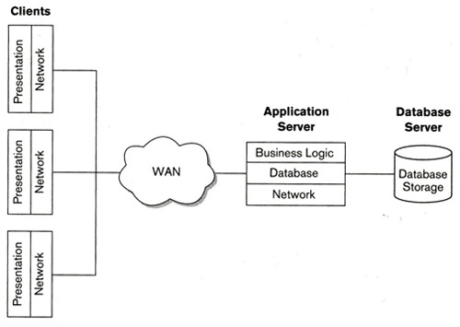

**Back-End**

***Description:***

The software architecture for an airline reservation system typically involves multiple layers, components, and subsystems to handle various functions and processes. Here are some of the key components and layers:

a. Presentation Layer: In this layer, user interaction and user interface management are handled. It consists of elements like web pages, mobile applications, or desktop programs that customers use to make or maintain bookings.

b. Application Layer: The reservation system's business logic and functions are housed in this layer. It consists of elements including reservation systems, payment processors, and customer relationship management (CRM) programs.

c. Data Layer: This layer is in charge of organizing and maintaining data pertaining to bookings, flights, clients, and other pertinent details. Databases, data storage systems, and data processing engines are some of its constituent parts.

d. Integration Layer: This layer simplifies the integration of multiple airline reservation system components and subsystems. It has parts like middleware, web services, and APIs that allow data sharing and communication across various subsystems.

e. Infrastructure Layer: The resources and underlying infrastructure needed to enable the airline reservation system are provided by this layer. It consists of elements that house and run the system, including servers, networks, and cloud computing platforms.

1. 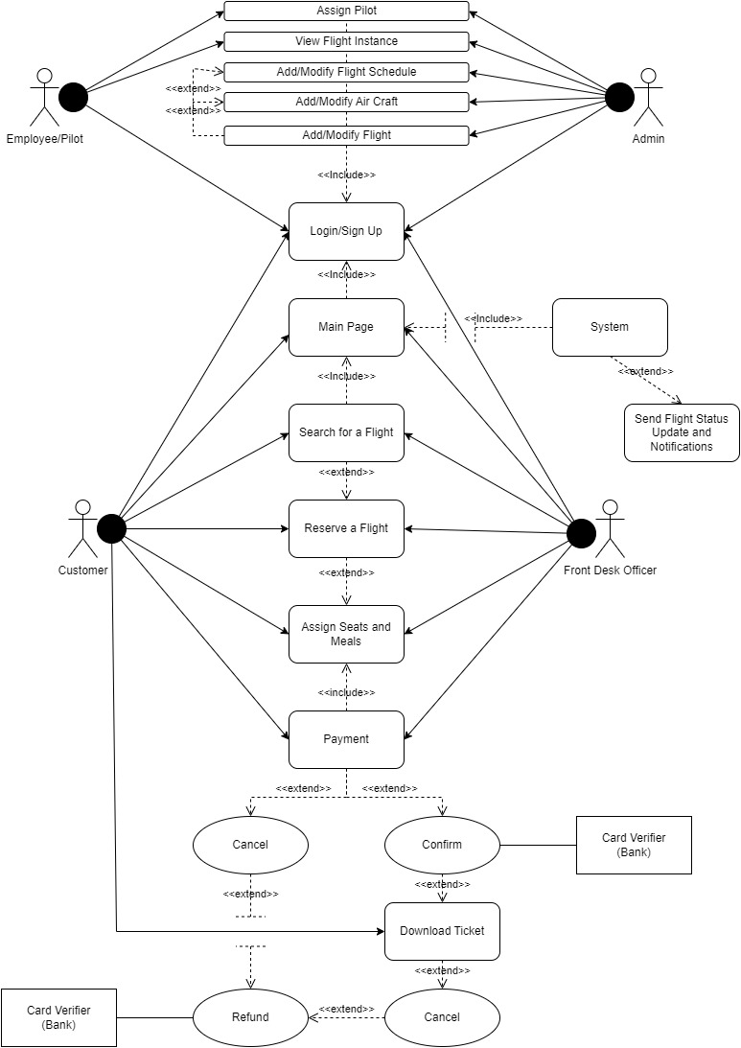***Use Case Diagram:***
2. **A) Description of the Use Case Diagram:**

The System Use Case diagram highlights and explains how our wide array of users are going to interact with Sky Track.

**Customer:** Our customers can interact with most features of SkyTrack as this management system is designed for them after all. The features they have access to are Login/Sign up, Main Page, search for a flight, reserve a flight, choose seats and meals, and process payments through cash or credit card where they can confirm or cancel the transaction. Once the client confirms their payment, they are able to download their ticket. If they ever choose to cancel their flight, they are able to do that and receive a percentage of the payment back as a refund. The user will also have access to the notifications system which is able to send flight status such as boarding, flying, landing as well as update notifications. Note that the user is unable to use any of the mentioned features without logging in first.

**Front Desk Officer:** Is the employee present at a certain branch of the airline company who is able to assist customers who do not wish to book their own airplane ticket. As such, Front Desk Officers have access to the same features as the customer, in order to fulfill their needs and help them choose the package most suitable for them.

**Admin:** The admin has access to special features that are only available to them, accessible through login to an admin account, such as the add/modify aircraft feature, similar to this, there is the add/modify flight and add/modify flight schedule features. And of course, the admin is able to assign which pilot is taking which flight and can check the flight instance.

**Pilot/Employee:** After logging in, pilots and employees have very limited features mainly including the assign pilot feature where a pilot or employee can choose which flight to board and the check flight instance feature.

1. **B) Activity Diagram:**

The following diagram is to discuss the activity diagram of the admin and it shows the activities and actions within the system. The activity diagram below is designed to show the user’s activity.

At first, a user logs-in to the system, either as a customer, admin, or employee/pilot. There is an option of a non-valid user, which is either a user that is not stored in our database, or because the user has entered incorrect credentials. This is why this option will yield to an error message, and

Will prompt the user to try to log-in again.

**Admin:**

As the admin, the user has two options. They can assign pilots and view flight instances. Additionally, through choosing to view flight instances, the admin has options to modify or add new flight schedules, cancel flights, and assign/modify assigned aircraft. All these features then direct to a decision node to log-out from the session.

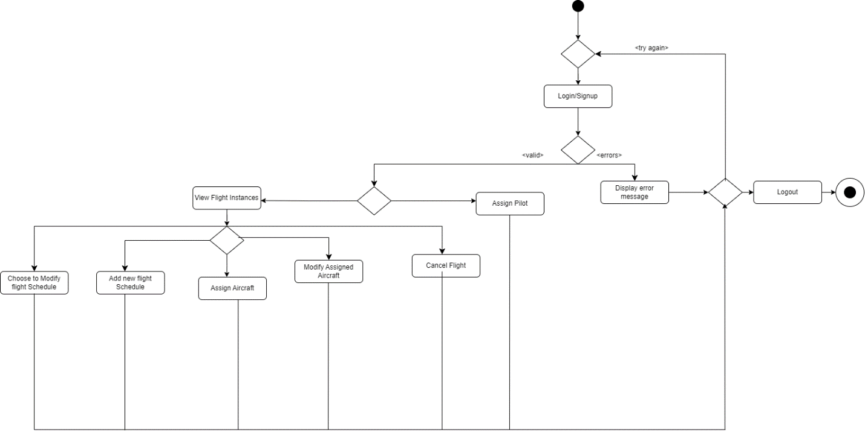

**Customer And Front Desk Officer:**

As the customer or Front Desk Officer, after login, the user is able to view main page. Accordingly, the user can start the process of searching for a flight, reserving a flight, assigning seats and meals for their travel, and initiate the payment process. The user is directed to two payment options, either to pay by cash at the front desk or by credit card. This then leads to a decision node, where the user is asked to confirm their reservation and is given the option to cancel it and log out. If the user confirms the payment, they can optionally download the ticket. Furthermore, the user is then led to a different decision node, where they can logout of the website, and they are given the right to cancel the flight and request a refund on their pay, where the transaction process is verified, and the user can then logout from the session.

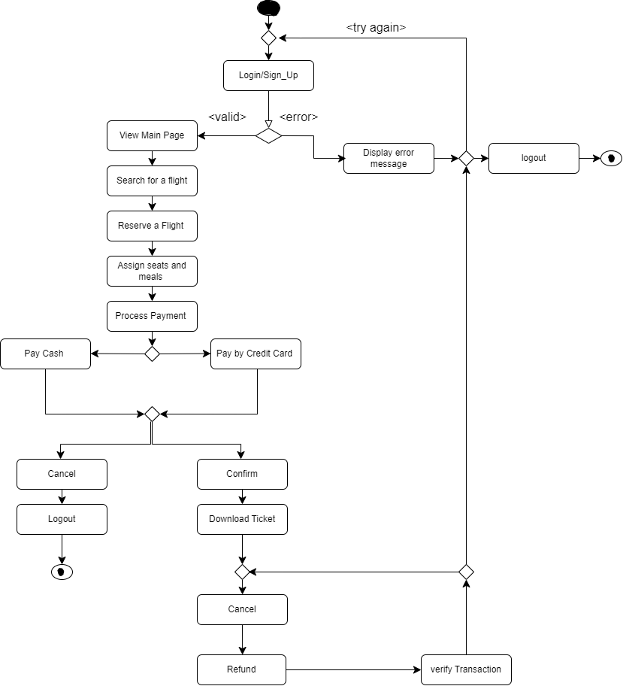

**Employee:**

As the employee, the user is given to options. They can assign pilots and only view flight instances. Then these two features are directed to a decision node to log out or start a new process.

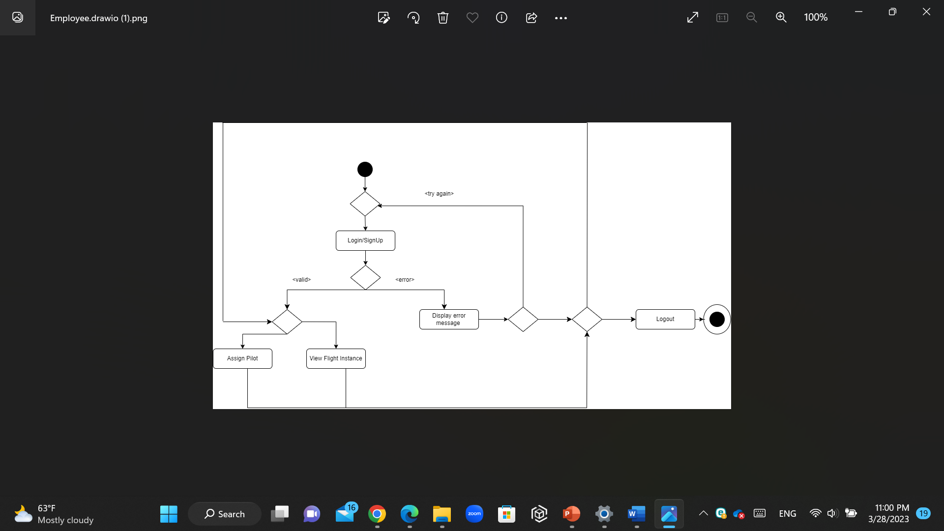

**IV. C) Sequence Diagram:**

The following shows the sequence diagram for our system (for the teller user). The sequence diagram shows the exact sequence of events and messages, in chronological order.

The sequence diagram above depicts the sequence of events and messages for the employee/pilot. The employee should first login. Upon entering their credentials, the system will verify if the credentials are valid. If they were, the employee logs in and can successfully view the main page; otherwise, the employee is asked to try again. After login, the employee can view flight instances, and the system will return the details. Also, they can request a pilot, where the system then checks the availability of the pilot in order to accept or reject the request. If the pilot is available, the employee is informed to notify the pilot. If not, they are asked to choose another pilot.

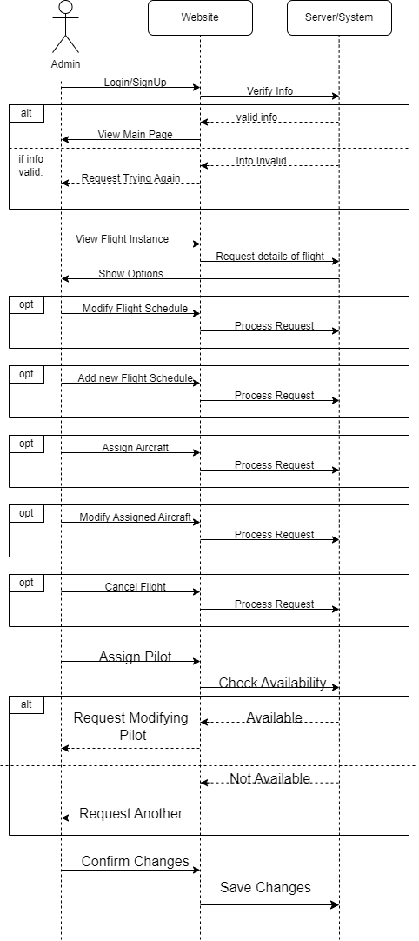Admin:

The sequence diagram above depicts the sequence of events and messages for the admin. The admin should first login. Upon entering their credentials, the system will verify if the credentials are valid. If they were, the admin logs in and can successfully view the main page; otherwise, the admin is asked to try again. After login, the admin can view flight instances, and the system will return the details. The admin is given many options. They can modify or add new flight schedules, cancel flights, and assign/modify assigned aircraft. Also, they can request a pilot, where the system then checks the availability of the pilot in order to accept or reject the request. If the pilot is available, the admin is informed to notify the pilot. If not, they are asked to choose another pilot. Lastly, the admin is asked to confirm changes and they will be saved in the system accordingly.

1. 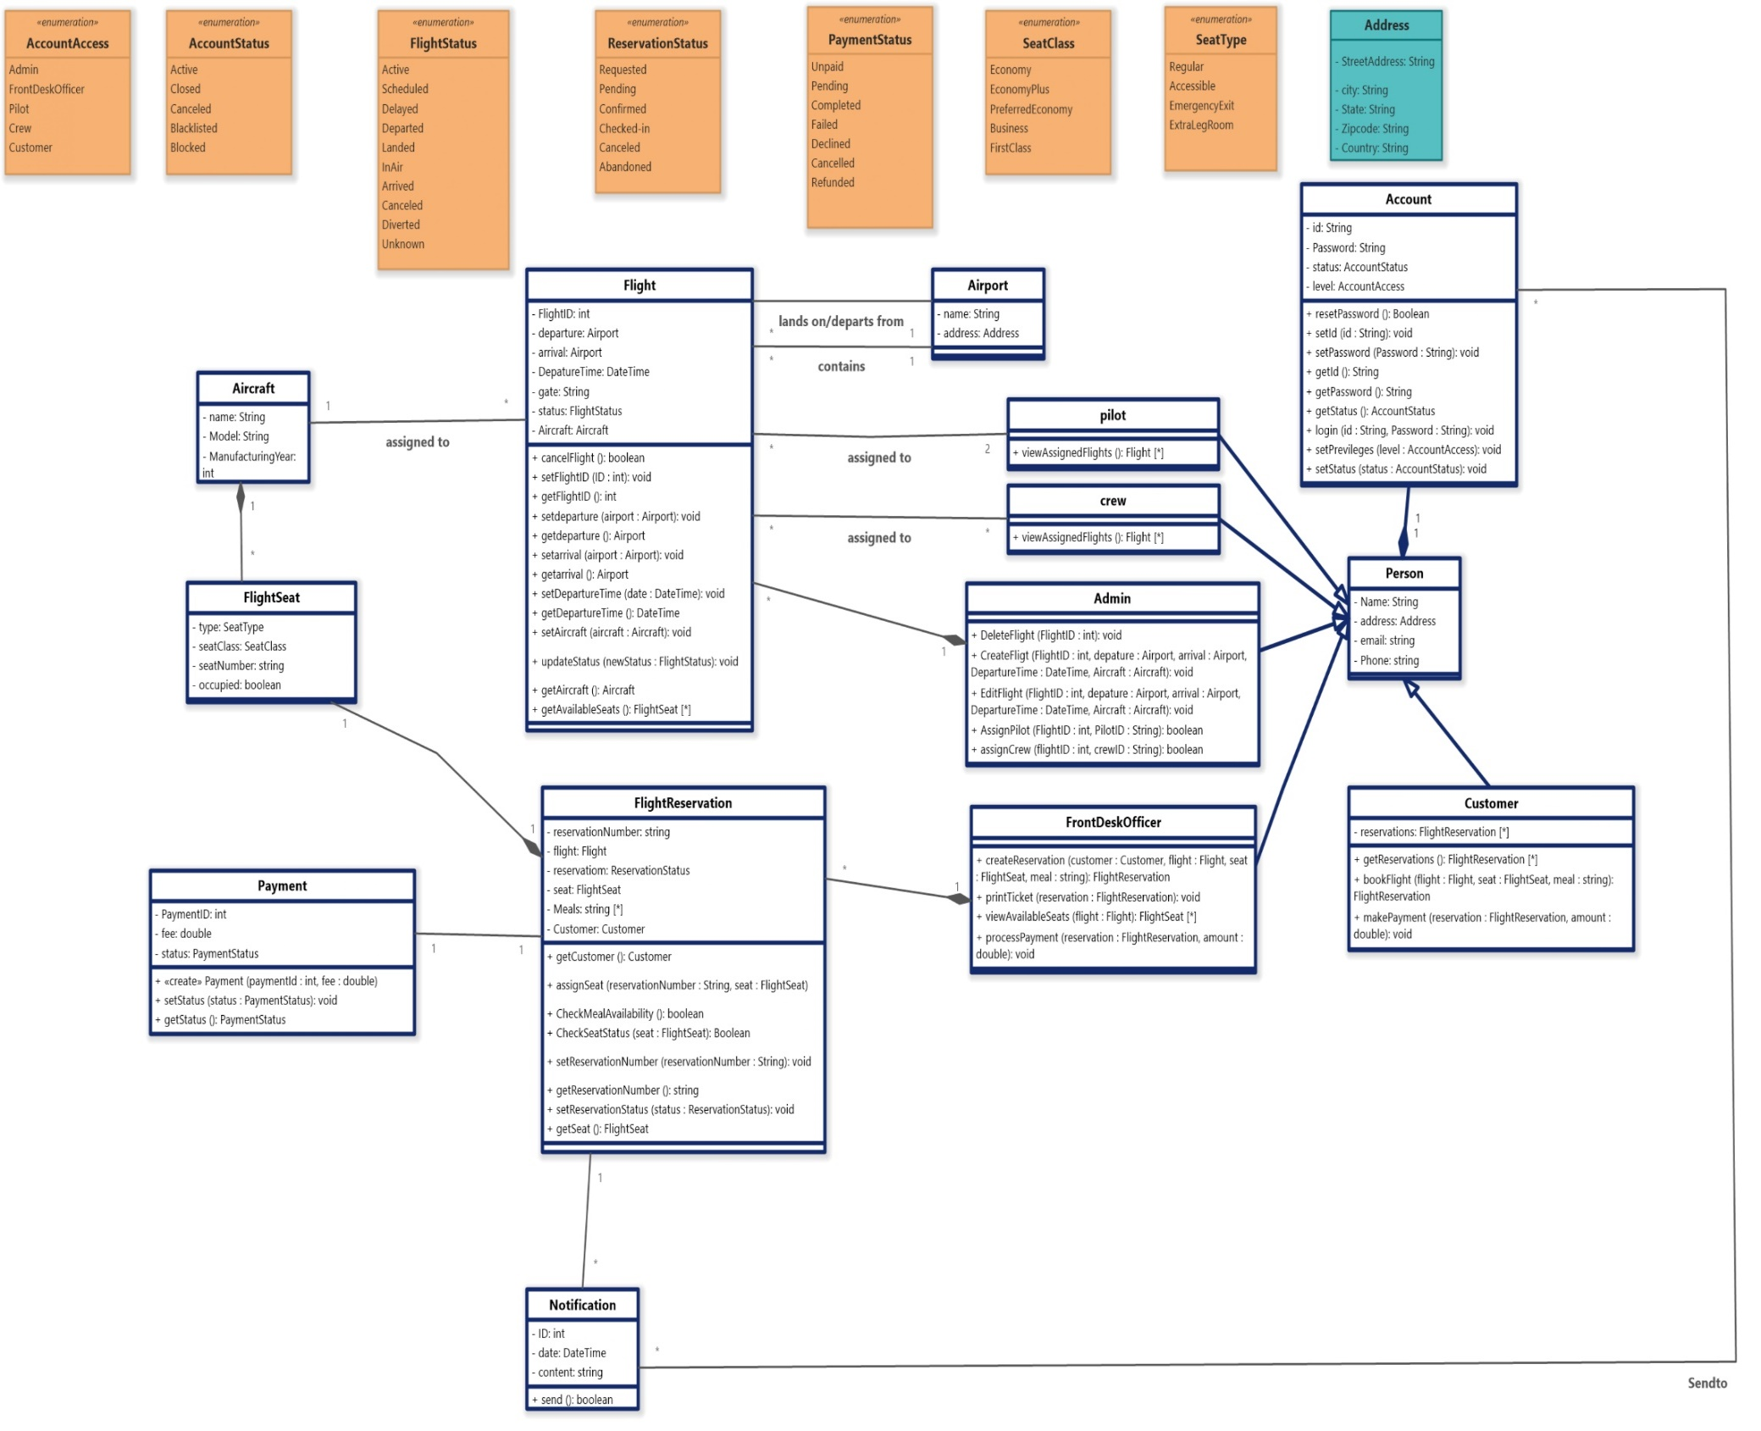***Class Diagram:***

The class diagram above shows the fourteen main classes, seven Enumerations and one Datatype in our system Classes: Account, Admin, Person, Customer, Notification, Payment, Flight, Airport, Aircraft, FlightSeat, FlightReservation, FrontDeskOfficer, Pilot and Crew. Enumerations: AccountAccess, AccountStatus, FlightStatus, ReservationStatus, SeatClass, PaymentStatus, SeatType. Datatype: Address. Each class shown includes its corresponding attributes and methods. The relationship between classes is described below:

• FrontDeskOfficer and FlightReservation have a one-to-many relationship, where a front desk officer can create 0 or more flight reservations, but a flight reservation belongs to one front desk officer.

• Flight and crew have a many-to-many relationship, where a flight can be assigned to multiple crews and a crew can be assigned to multiple flights.

• Flight and pilot have a many-to-many relationship, where a flight can be assigned to two pilots (but there is 2 to many relationships so it is essentially a many-to-many) and a pilot can be assigned to multiple flights.

• Flight and Airport have a one-to-many relationship, where a flight departs from one airport and arrives at another airport.

• Aircraft and Flight have a one-to-many relationship, where an aircraft can be assigned to 0 or more flights and a flight belongs to one aircraft.

• FlightReservation and FlightSeat have a one-to-one association, where a flight reservation is assigned to one flight seat and a flight seat is assigned to one flight reservation.

• Payment and FlightReservation have a one-to-one association, where a payment is associated with one flight reservation and a flight reservation has one payment.

• Admin and Flight have a one-to-many association, where an admin can create/delete/edit multiple flights and a flight is created/deleted/edited

• Aircraft and Flight have a one-to-many relationship, where an aircraft can be assigned to 0 or more flights, but a flight can only be assigned to one aircraft.

• FlightReservation and FlightSeat have a one-to-one relationship, where a flight reservation can only have one flight seat assigned to it, and a flight seat can only be assigned to one flight reservation.

• Payment and FlightReservation have a one-to-one relationship, where a payment is associated with one flight reservation, and a flight reservation can have only one payment.

• Admin and Flight have a one-to-many relationship, where an admin can create, edit, or delete 0 or more flights, but a flight belongs to only one admin.

• Account and Person have a one-to-one relationship, where an account is associated with one person, and a person can have only one account.

• Pilot, Crew, FrontDeskOfficer, and Admin are all subclasses of Person, indicating an "is a" relationship. A pilot, crew member, front desk officer, or admin is a person.

***Conclusion:***

Sky Track is a state-of-the-art project consisting of multiple platforms all sharing an airport management system. Our team, DTE, is working tirelessly to create an interface that prioritizes user and operator comfort.

We are developing several features for this management system in order to track book and manage flight details for clients simply and efficiently.

For phase 1: This document first covers the stakeholders or the variety of users who will be using this system. Then, we briefly discuss what makes our system unique and different from others. Moving on to the system and user requirements, we explained the features being implemented on this system more thoroughly. The functional features include: Login/sign up, User Data, Main Page, Book a flight tab, My schedule tab, Passengers Preference, and Loyalty Program. As for the non-functional features: Simplicity of the design, Performance, Security, Interoperability, Availability, Usability, and Maintainability.

Finally, a system evolution diagram is included explaining the accessibility and dependence of users on features of SkyTrack.

As for phase 2: First, the document discusses Software Architecture Design and Components. Then we go over the Use Case Diagram which shows the access of each user to which features of our website.

After that, we expound on the activity diagrams of each user of our system, Customer, Front Desk Officer, Employee/Pilot, and Admin.

This document then features the sequence diagrams of two of our users: Employee/Pilot and Admin.

Finally, we display a diagram of all of our available classes, their attributes, functions, and relations.